

Physics Exam Semester Two
Written Paper 2ABPHY
Question/Answer Booklet

Student name: _______________________________________
Teacher name: _________________

Time allowed for this paper
Reading time before commencing work: Ten minutes
Working time for paper: Three hours

Material required/recommended for this paper

To be provided by the supervisor
This Question/answer booklet; Formulae and constants sheet

To be provided by the candidate
Standard items: pens, pencils, eraser or correction fluid, ruler, highlighter

Special items: scientific non-programmable calculator

Important note to candidates
No other items may be taken into the examination room. It is your responsibility to ensure that you do not have any unauthorised notes or other items of a non-personal nature in the examination room. If you have any unauthorised material with you, hand it to the supervisor before reading any further.

All calculations are to be set out in detail. Marks may be awarded for correct equations and clear setting out, even if you cannot complete the calculation. Express numerical answers to two (2) or three (3) significant figures and include units where appropriate.

Student Marks
Section | Percentage of paper | Maximum mark | Student Mark
Section One  21 questions | 40 | 64
Section Two  7 questions | 50 | 80
Section Three  1 -2 questions | 10 | 160
Student Score
Student Percentage
Structure of this paper

Section of exam | Suggested working time | Number of questions | Number of questions to be attempted | Marks available
Section One | 60 minutes | 21 | all | 64
Section Two | 75 minutes | 7 | all | 80
Section Three | 15 minutes | 1 | all | 16
Total marks |  |  |  | 100

Instructions to candidates

- The rules for the conduct of Western Australian external examinations are detailed in the Year 12 Information Handbook 2010. Sitting this examination implies that you agree to abide by these rules.

- Write your answers in this Question/Answer Booklet.

- A blue or black ballpoint or ink pen should be used except for graphs were a pencil should be used.

- Working or reasoning should be clearly shown when calculating answers and answers should be given to three (3) significant figures were appropriate.

- You must be careful to confine your responses to the specific questions asked and to follow any instructions that are specific to a particular question.

- Spare pages are included at the end of this booklet. They can be used for planning your responses and/or as additional space if required to continue an answer.
  - Planning: If you use the spare pages for planning, indicate this clearly at the top of the page.
  - Continuing an answer: If you need to use the space to continue an answer, indicate in the original answer space where the answer is continued, i.e. give the page number. Fill in the number of the question(s) that you are continuing to answer at the top of the page.

Section one: Short answer 64 marks

This section has twenty one (21) questions. Answer in the spaces provided.
Suggested working time for this section is 70 minutes
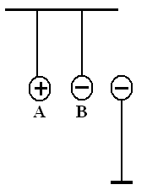
- Three charged spheres are placed near each other and held. Spheres A and B are free to move but sphere C is in a fixed position. Once released, describe the initial motion of A and B. (2 marks)

The negative will move right towards the positive [1 mark]
The positive will move towards the negative and probably touch
[1 mark]

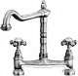
- A single outlet connected to both taps over a kitchen sink is supplied with cold water at 8.0⁰C and hot water at 64⁰C. Two students are measuring the flow and finds out that the cold water tap is giving a flow of 8.0 litre min⁻¹. They then adjust the hot water tap to give a total flow rate of 14.0 litre min⁻¹ through the outlet. One student then measured the temperature of the warm water. What was this temperature?
(2 marks)
Mass hot water = 14 – 8 = 6 litres min⁻¹

mcΔT (hot water) = mcΔT (cold water)
as specific heat, c, is constant
8(T_{f} – 8) = 6(64 – T_{f}) [1 mark]
8T_{f} – 64 = 384 – 6T_{f}
8T_{f} + 6T_{f} = 384 + 64
14T_{f} = 448
T_{f} = 32 ⁰C [1 mark]

- Water is the main liquid used in car cooling systems. Explain, in terms of physics principles, why water is used. (3 marks)

Water has a high specific heat [1 mark]
Water can easily flows around cooling system [1 mark]
Water can absorb a large amount of energy before increasing temperature [1 mark]

- On hot summer days at the beach you can sometimes see people relaxing on a deck chair with a wet cloth over their forehead. Referring to heat energy concepts, explain how a wet cloth placed on the forehead can help a person stay cool. (3 marks)
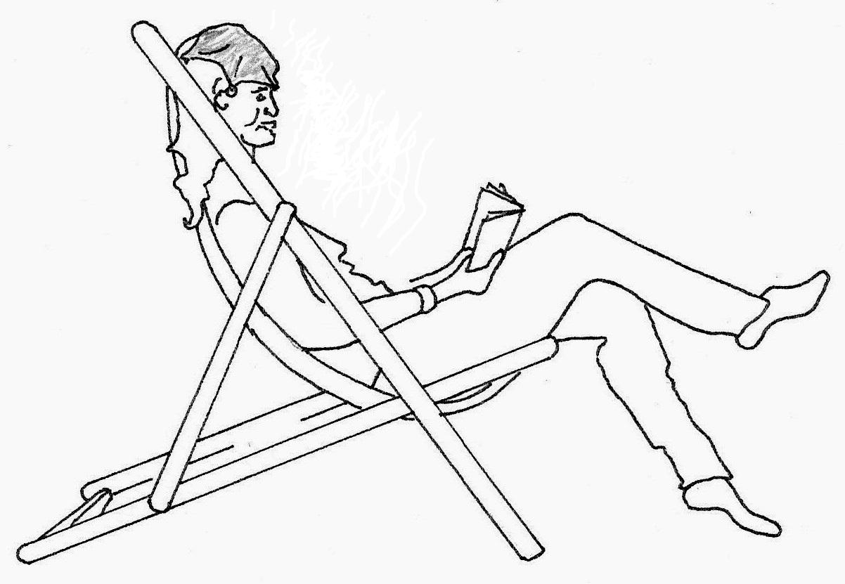
Wet Cloth

Water in the wet cloth evaporates. ✓

Energy needed for the phase change, the latent heat of vaporisation, is taken from the forehead. ✓ This lowers the temperature of the forehead. ✓
Or – water particles with higher Kinetic Energy escape from the cloth/forehead lowering the average kinetic energy of particles, hence lowering temperature.

- A sample of skull bone from a recently deceased human was tested and found to have an activity of 0.320 Bq. A similar size sample was obtained from a human skull uncovered at an archaeological site and its activity was measured. Over a one hour period 324 counts were registered on a Geiger counter. The half life of radioactive carbon is approximately 5730 years.

(a) Determine the activity (becquerels) for the archaeological sample.
(1 mark)
Activity = decays per second 1 hour = 60 × 60 = 3600 seconds
A = 324 / 3600 = 0.09 Bq ✓

(b) Determine the age of the skull from the archaeological site.

(3 marks)
A = 0.09 Bq A₀ = 0.320 Bq t_{½} = 5730 years
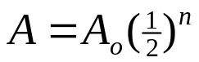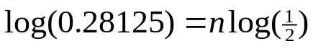
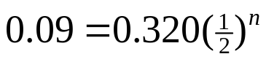 ✓ 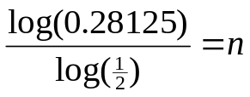
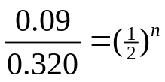 n = 1.83 ✓
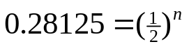 t = n × t_{½}
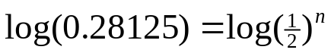 t = 1.83 × 5730 = 10,485.9
Age t = 10,500 years ✓
Or guess check and improve method if used by your school
0.32 ➔0.16➔0.08 = 2 half lives, so a little less than 11,460 yrs

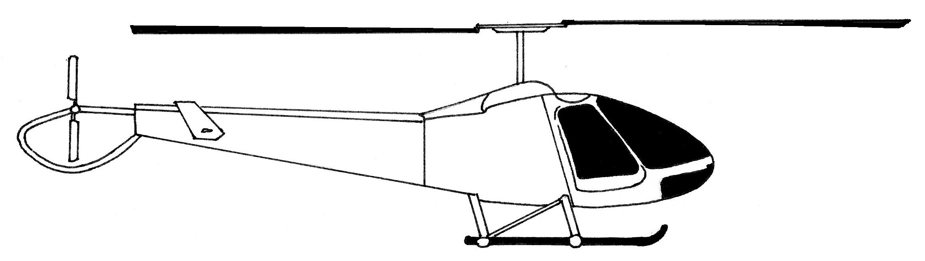
20.8°
Force from rotors acts at an angle of 20.8° to the vertical
6. A helicopter of mass 3100 kg is kept at a constant height and propelled forwards by a single force from its rotors acting at an angle of 20.8 ° to the vertical.

- Draw a vector diagram and determine the magnitude of the force from the rotors.

20.8°
Force from rotors acts at an angle of 20.8° to the vertical

W = mg
W = 3100 × 9.8
W = 30 380 N
20.8°
F_{rotor} diagram ✓

(3)

cos 20.8° = 30 380 / F_{rotor}
F_{rotor} = 30 380 / cos 20.8° ✓

F_{rotor} =32 498.03762 F_{rotor} = 3.25 × 10⁴ N ✓

b) Calculate the work done by the force from the rotors to move the helicopter horizontally forwards by a distance of 65.0 m.
(If you could not solve part a) let the force from the rotors = 3.00 × 10⁴ N)
F_{rotor} =32 498.03762 s = +65.0 m θ = 20.8°
Concept, work done by F_{component} in direction of displacement
W = F_{rotor} × sin θ × s
W = 32 498.03762 × sin 20.8° × 65 ✓ = 750 118.1625

W = 7.50 × 10⁵ J ✓

(2)

Wine glass
Cracks in the glass where it has come into contact with hot water
7. If a thin walled drinking glass (such as a wine glass) is dipped into very hot water the glass often cracks.

Referring to the principles of Kinetic Molecular Theory, explain why this happens.

(3 marks)
This is due to thermal expansion and the fact that glass is a heat insulator.
- Placement of the glass into hot water causes a transfer of heat energy into glass. ✓
- The glass expands (an increase in potential energy)✓.
- The glass is an insulator so cannot distribute the energy quickly and expansion remains localised, this causes the glass to crack (thermal shock). ✓

8.
- Explain why the metal copper is a better electrical conductor than rubber. (2 marks)

Copper has delocalised negatively charged electrons. ✓
They can be influenced to move by an electric force field through the copper material. ✓ Or similar

- Explain why the metal copper is a better heat conductor than rubber. (2 marks)

The delocalised electrons are free to move in the material ✓ They have relatively low mass and low inertia at this scale so can freely transmit Kinetic energy via collisions. ✓ Or similar

- Students are using model cars to test the effects of collisions on a frictionless track. A red car of mass 8.00 kg is moving East at 12.0 m s⁻¹ when it collides with a blue car of mass 5.00 kg travelling West at 9.00 m s⁻¹. After the collision the red car is moving East at 2.50 m s⁻¹ .
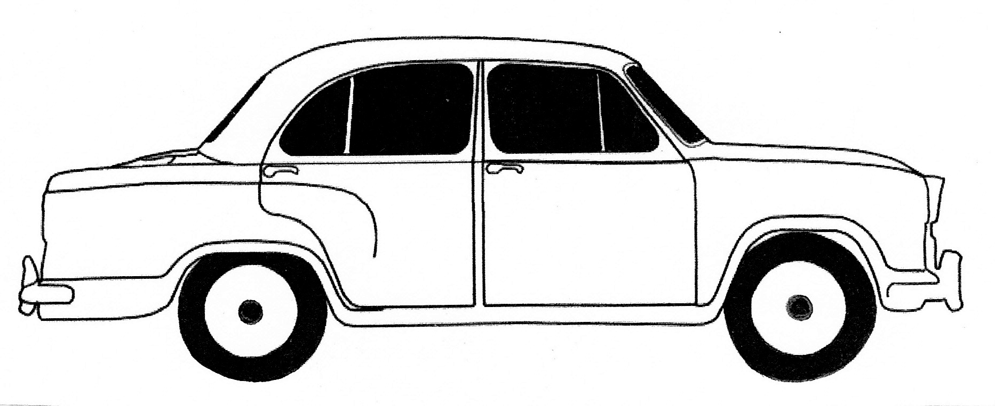
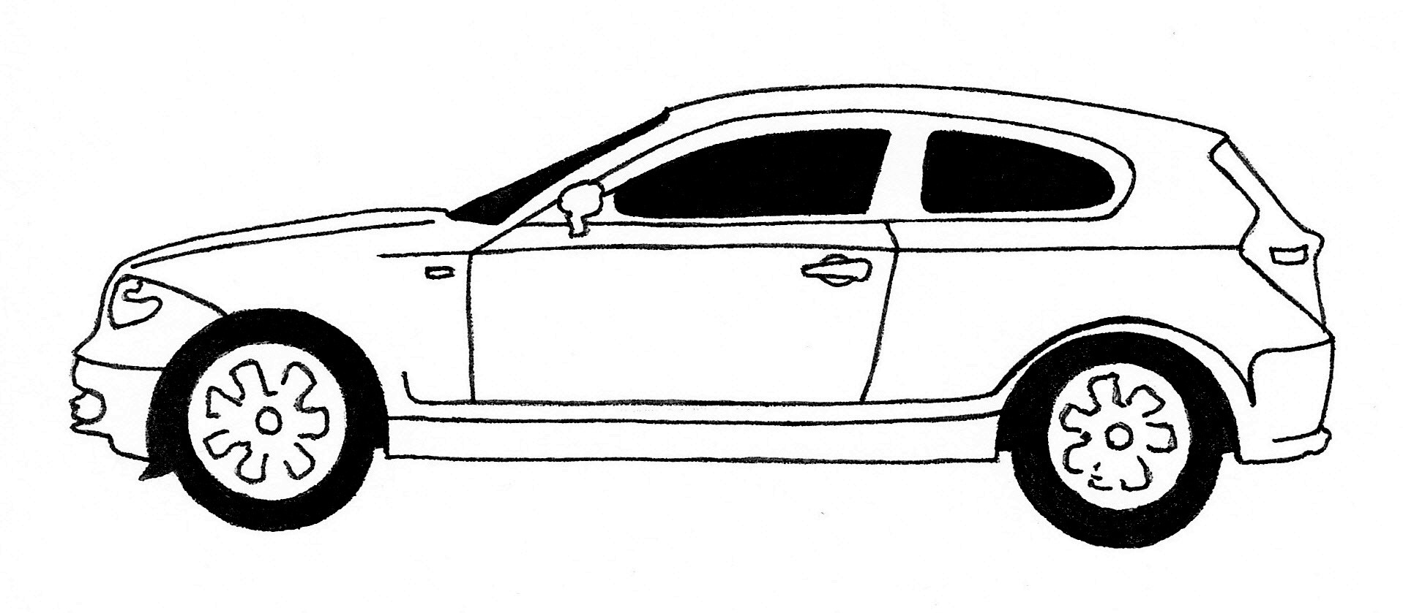
8.00 kg 12.0 m s⁻¹
5.00 kg 9.00 m s⁻¹

- Determine the velocity of the blue car after the collision. (2 marks)

Let East = +ve,
m₁ = 8.00 kg u₁ = +12.0 m/s m₂ = 5.00 kg u₂ = -9.00 m/s v₁ = +2.50
ΣP_{before} = ΣP_{after} m₁u₁ + m₂u₂ = m₁v₁ + m₂v₂
(8.00 × +12.0) + (5.00 × -9.00) = (8.00 × +2.50) + (5.00 × v₂) ✓
v₂ = +6.20 m/s ✓ (+ = East)

- The kinetic energy of the cars after the collision is 121 J. Compare this with the kinetic energy of the cars before the collision. What conclusion can you make about energy transformations in the collision? (2 marks)
KE before = _{½} m₁u₁² + ½ m₂u₂² = ½.8 × 12² + ½.5 ×(-9)² = 778.5 J✓

Kinetic energy has reduced. It has transformed to sound and heat. ✓
(The collision was inelastic)

10. Fill in the blanks to complete the following sentences: (1 mark)

- The process of heat transfer within the atmosphere above a desert that leads to wind formation is called CONVECTION

- Heat loss by the process of RADIATION from a thermos flask can be minimized by the double layered glass wall in the flask. The glass is silvered with a vacuum between the layers.

  - A child’s toy robot requires 4.50 V to run. The batteries supply a current of 3.00 x 10² mA and a power output of 1.35 W. Calculate the electrical resistance of the robot. (2 marks)

I = 0.300 A P = I²R
1.35 = (0.30)² x R [1 mark]
R = 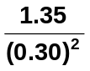
R = 15.1 Ω [1 mark]

  - Two students are studying for their Physics Examination. How much energy would a kettle needed to supply in order to heat 565 mL of water initially at 18⁰ C to 90⁰ C to make the students a cup the tea? (2 marks)

Q = mcΔT
= 0.565 x 4180 x (90 – 18) [1 mark]
= 170042.5
Q = 1.70 x 10⁵ J [1 mark]

13. A research assistant was trying to determine the latent heat of fusion of a new material. He recorded both the energy added and the temperature of the material. The graph below shows his results.
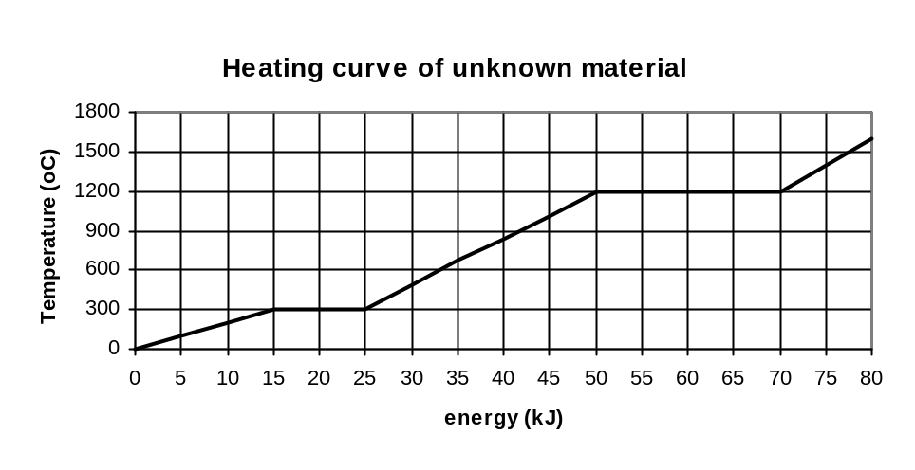
He determined that the latent heat of fusion for this material was 2.00 x 10⁵ J kg⁻¹. What mass of material was he using? (2 marks)

Q for latent heat = 10 kJ [1 mark] Q = mL
10 000 = m x 2.00 x 10⁵
m = 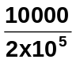
m = 0.0500 kg [1 mark]

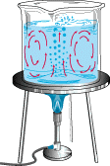
  - a. The diagram on the right shows a form of heat transfer. Name this form of heat transfer and explain the physics about how it occurs.

Convection and occurs in fluids (gases and liquids) [1 mark]

Heat energy increases E_{k} of molecules [1 mark]

Particles move faster and further apart so become less dense and rise up
When cooled, less E_{k} so becomes more dense and sinks [1 mark]

(2 marks)
b. Name a natural phenomena that is a result of this form of heat transfer. (1 mark)
Convection currents or any other appropriate phenomena [1 mark]
  - An electrical circuit on 24.0 V and a current of 200 mA is run for 4.0 minutes. How much work was done during this time? (2 marks)

W = VIt W = VIt
= 24 x 0.2 x 240 [1 mark]
t = 4 x 60 = 1152 J
= 240 s
V = 24 W = 1.15 x 10³ J [1 mark]
I = 0.2 A

  - Tom was given four 3.00 Ω resistors. Draw a diagram below to show how he could connect the four resistors to give a total resistance of 4.00 Ω. (2 marks)

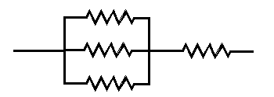

  - Ice making and dispensing machines are part of some expensive fridges. In one particular fridge, 1.50 kg of water enters the insulated compartment at 15.0 ⁰C and needs to be cooled to produce ice cubes which are at -5.00 ⁰C.
- How much energy does the fridge remove from the water for this to occur? (3 marks)

Q = (1.5 x 4180 x 15) + (1.5 x 3.34 x 10⁵) + (1.5 x 2100 x 5] [2 marks]

Q = 94050 + 501000 + 15750

Q = 610800

Q = 6.11 x 10⁵ J [1 mark]

- The fridge is connected to the 2.40 x 10² V power supply and receives 2.00 A of current. How long will the ice cubes take to make?
[If you couldn’t obtain an answer from part (a) then use 6.00 x 10⁵ J] (2 marks)

Q = VIt
610800 = 240 x 2 x t [1 mark]
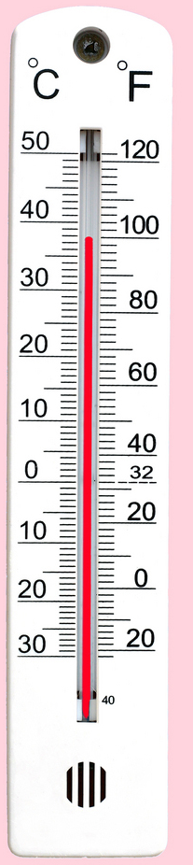
t = 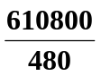
t = 1272.5

t = 1.27 x 10³ s [1 mark]

If use 6.00 x 10⁵ J then 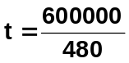
t = 1.88 x 10³ s

  - The weather thermometer on the right is used to show the temperature in degrees Celsius and Fahrenheit.

a) What is the reading in degrees Celsius on the thermometer?
38 ⁰C [1 mark]
______________________________________ (1 mark)
b) What is the absolute error of the reading?
±0.5 ⁰C [1 mark]
_____________________________________ (1 mark)

  - Within the oval area, where could a charged particle P be placed so that it experiences no net force? You will need to draw in the field lines to justify your placement. (4 marks)

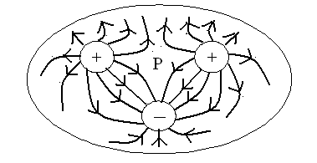
1 mark for arrows
1 mark for P
2 marks for diagram

  - Sam has set up an unusual experiment in static electricity to investigation charged particles. A small sphere is suspended 1.50 cm above another sphere in a frictionless pipe. The bottom sphere has a charge of +15.0 nC, and both have a mass of 0.300 g. Calculate the charge on the top sphere? (Hint: Consider all forces acting not just the electrical forces.) (4 marks)

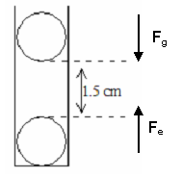
F_{g} = F_{e}
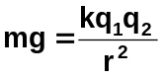 [1 marks]
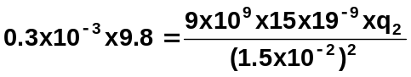 [2 mark]
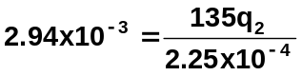

135q₂ = 2.94 x 10⁻³ x 2.25 x 10⁻⁴
= 6.615 x 10⁻⁷

q₂ = +4.9 x 10⁻⁹ C [1 marks]

(4.9 nC)

  - In another situations, Jeremy has set up two freely hanging charged spheres which have a charge of +10.0 nC and -6.00 nC respectively. Jeremy brings the spheres together to touch each other and then releases them. Once released the particles settle 8.00 cm apart from each other. Calculate the force they exert on each other at this time? Show all working. (4 marks)

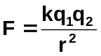+10 -6

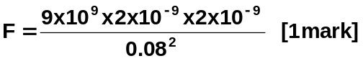
+10-6 = +4

+2nC +2nC F = 5.63 x 10⁻⁶ N repulsion
[1 mark] [1 mark]

[1 marks]

Section two: Problem-solving 80 marks

This section has seven (7) questions. Answer in the spaces provided.
Suggested working time for this section is 90 minutes

1. A university student was heating a 9.45 kg sample of a solid material in an insulated container with an electrical heating coil which supplied heat at a rate of 365 W.

He measured the temperature of the substance every minute and the graph below shows the change in temperature over a 12.0 minute period.
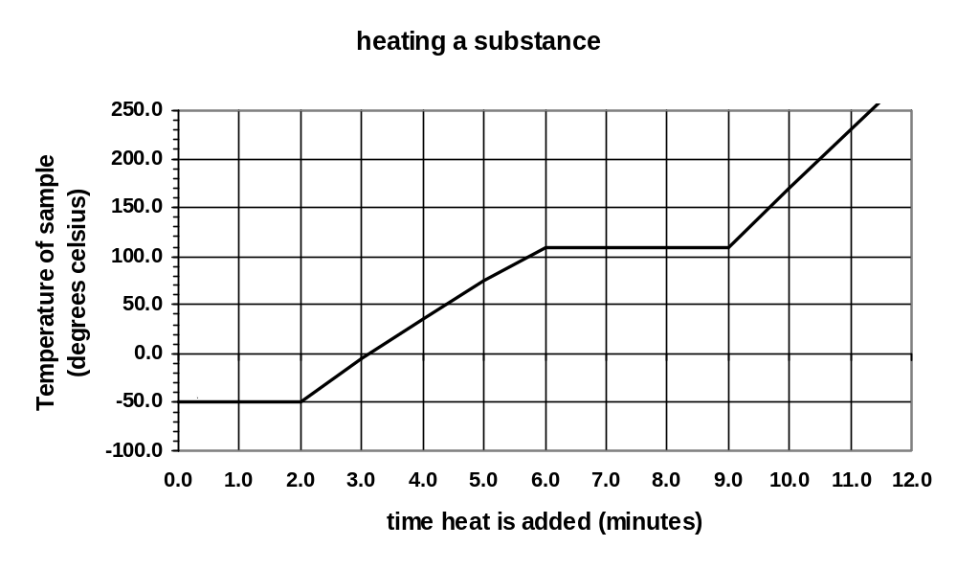

a. What is the melting temperature of the solid? (1 mark)

-50 ⁰C [1 mark]

b. What phase(s) is/are present between points C and D on the graph? (1 mark)

liquid and gas [1 mark]

- d. How much heat energy was absorbed while the liquid was evaporating? (2 marks)

t = 3 x 60 E = Q = Pt
= 180 s = 365 x 180 [1 mark]
energy = 65700
= 6.57 x 10⁴ J [1 mark]

e. Calculate the latent heat of evaporation for the substance. (2 marks)

Q = mL
65700 = 9.45 x L [1 mark]

L = 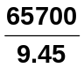
L = 6952

L = 6.95 x 10³ J kg⁻¹ [1 mark]

- f. Which is greater, the specific heat of the liquid or that of the gas? Explain using the graph and without using a calculation (2 marks)

Liquid, [1 mark]

Gradient of graph is less so more energy is absorbed before change in temp. [1 mark

g. Calculate the specific heat for the substance in the liquid phase. (4 marks)

Liquid, [1 mark]

Gradient of graph is less so more energy is absorbed before change in temp. [1 mark

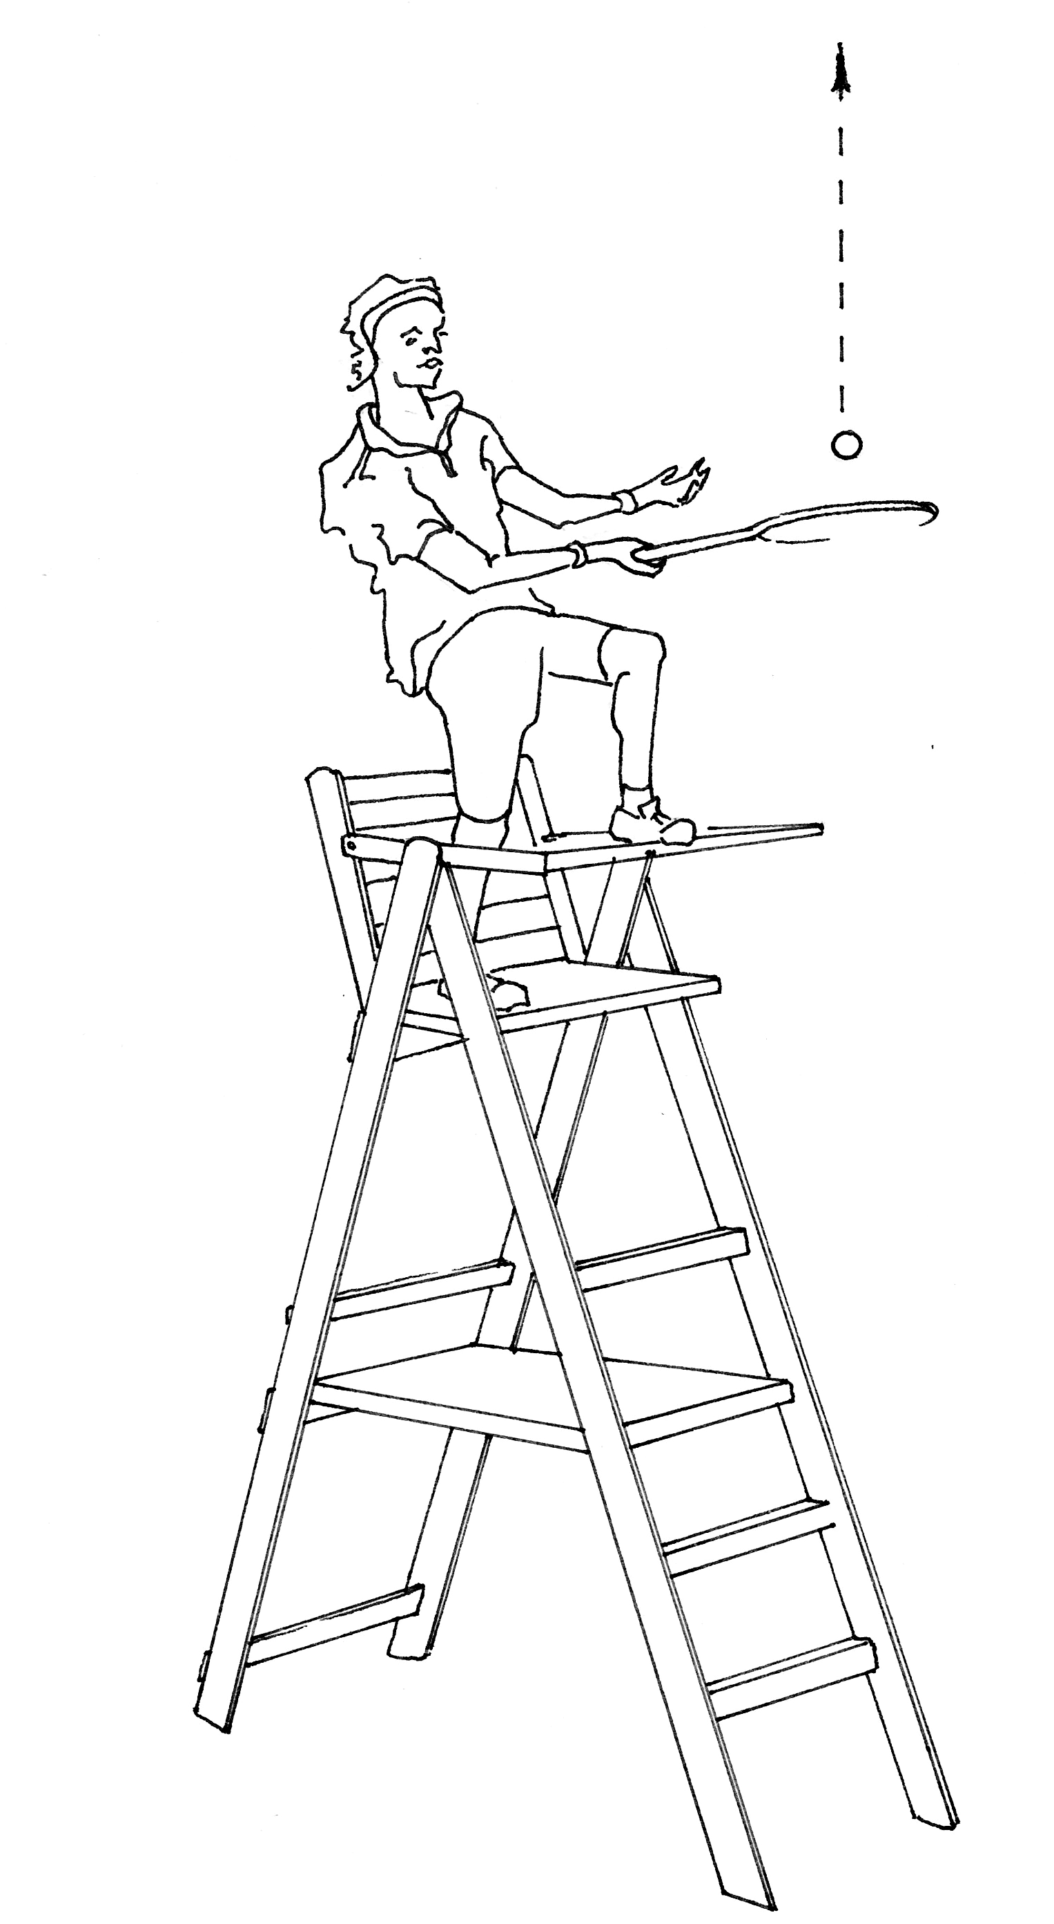
2. Rafael Nadal celebrates his Wimbledon victory by climbing onto the top of the umpire’s chair and smashing a tennis ball vertically upwards.
3.80 m

The ball is launched from a position 3.80 m above the ground with an initial velocity of 24.2 m s⁻¹ upwards.

The ball has a mass of 56.7 grams.

You may ignore air resistance in this question.

- Calculate the maximum height that the ball reaches above the ground. (3 marks)

Let up + +ve

u = +24.2 m/s a = -9.8 m/s² v_{max} = 0 s = ?

v² = u² + 2.a.s
0 = 24.2² + (2 × -9.8 × s) ✓
s = -24.2² / -19.6
s = 29.879.. ✓

s_{above ground} = 29.879 + 3.80 = +33.7 m ✓

- Calculate the velocity of the ball after 3.10 seconds.
(2 marks)

Let up + +ve

u = +24.2 m/s a = -9.8 m/s² v = ?

v = u + a.t
v = 24.2 + (-9.8 × 3.10) ✓
v = -6.18

v = -6.18 m/s (negative indicates down) ✓

- Calculate the flight time of the ball (the time taken for the ball to leave the racquet and reach the ground).
(4 marks)
Let up + +ve u = +24.2 m/s a = -9.8 m/s² s = -3.80

v² = u² + 2.a.s
v² = 24.2² + (2 × -9.8 × -3.80) ✓
v² = 660.12
v = - 25.6928 ✓ (negative indicates going down)

v = u + a.t
- 25.6928 = 24.2 + (-9.8 × t) ✓
- 25.6928 - 24.2 = -9.8 × t
t = -49.8928 / -9.8 t = 5.09 seconds ✓

Alternatively general solution of a quadratic using s = ut + ½ at²
-3.80 = 24.2t – 4.9t²
-4.9t² + 24.2t +3.80 = 0 (a = -4.9, b = 24.2, c = 3.80) to solution.

- Calculate the kinetic energy of the ball at the instant it reaches the ground.
(3 marks)

Let up + +ve u = +24.2 m/s a = -9.8 m/s² s = -3.80
m = 0.0567 kg

v² = u² + 2.a.s
v² = 24.2² + (2 × -9.8 × -3.80) ✓
v² = 660.12

KE = ½ m v²
KE = ½ 0.0567 × 660.12 ✓

KE = 18.7 J ✓

3.
- Some liquid alcohol of mass 0.65 grams was placed in a glass container and vaporised at 70ºC. The container with the vapour was placed in a large water bath that was kept at room temperature. The change in temperature of the alcohol was recorded for 1 minute. There was constant rate of energy output from the alcoholic substance such that 1165 J of energy was transferred out in a 50 second time period. The graph below shows the cooling curve produced. Assume that heat loss to the surroundings was negligible.

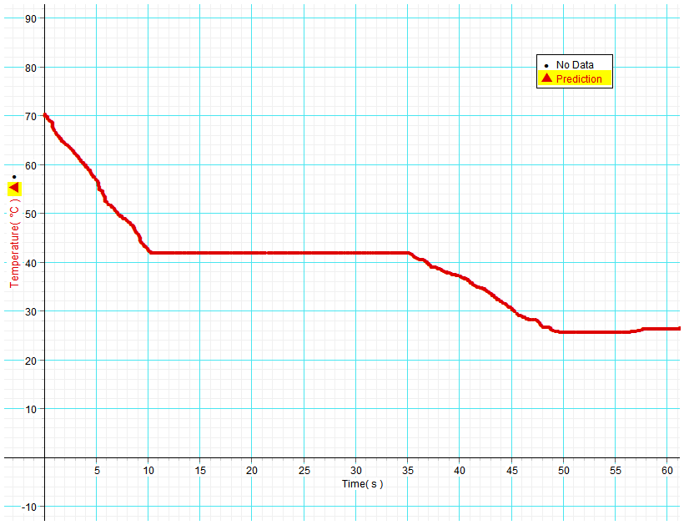
A
B
C
D
Cooling curve of alcoholic substance.

- From the graph, what comparison can you make between the specific heat capacity of the liquid alcohol versus the specific heat capacity of its vapour? No calculation is required.
(2)
C(vapour) is less than C(liquid) as seen from the steeper gradient of the vapour. ✓ The drop in temperature of the vapour occurs with less release of energy compared to the liquid. ✓ or similar

- What states of matter are present in the container during section BC? (1)
Vapour (gas) and Liquid ✓

- Determine the latent heat of vaporisation of the alcohol. (3)

Refers to graph to get 25 seconds of time for phase change
Q = 1165 J in 50 s which is 582.5 J in 25 s
m = 0.65 × 10⁻³ kg ✓

Q = m x L_{v}
i.e. L_{v} = Q / m = 582.5 / (0.65 × 10⁻³) ✓ L_{v} = 8.96 x 10⁵ J kg⁻¹ ✓

- In terms of the Kinetic Molecular Theory, explain why the temperature of the substance did not decrease while energy transferred from it to the water between 10 and 35 seconds. Define temperature as part of your answer.
(3)
At the condensation (boiling) point internal energy is released to water by a decrease in potential energy only. (Particle separation is reducing). ✓
The kinetic energy component of internal energy is unchanged. ✓
Temperature is a measure related to average kinetic energy of particles so this is constant.✓

- Consider ‘0.65 g of the vapour at 70°C’ and ‘10 kg of the liquid at 25°C’. Which of the two would you expect to have the highest internal energy? Discuss with reference to Kinetic Molecular Theory.
(3)
Internal Energy is the sum of all kinetic energy and potential energy of the particles that form the mass of a substance. ✓

Temperature is only related to the average kinetic energy regardless of the number of particles in a given mass of substance. ✓

The number of particles in 10 kg is vastly more than 0.65 g so internal energy of the 10 kg of liquid is likely to be much greater. ✓

4. A high speed electric train is tested on a track which is a straight line that runs from West to East. Motion sensors are placed along the track to investigate the motion. The data has been processed to make the velocity–time graph below. East is considered positive and the motion starts from the midpoint of the track.

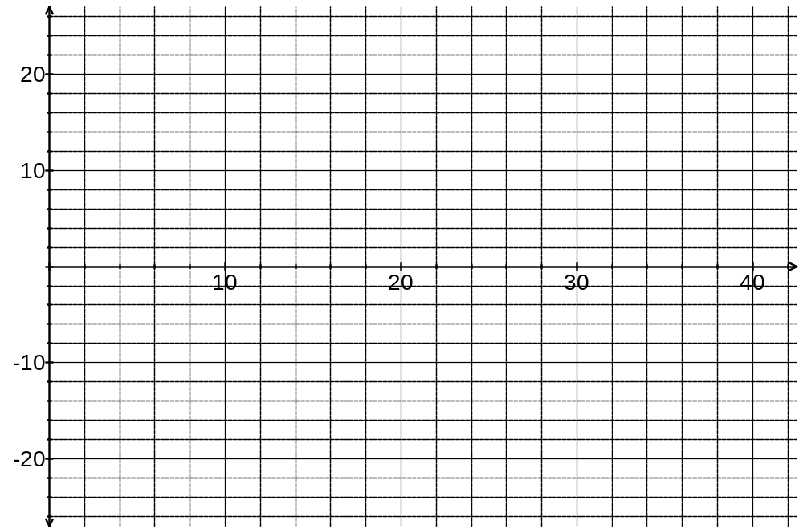
Time (s)
Velocity (m s⁻¹)

Use the graph to determine the following information:

- For how many seconds in total was the train stationery?
(1)
6 seconds (from t = 22 to t = 28) ✓

- Determine the acceleration of the train between 12 and 15 seconds.
(2)
t = 3 Δv = final – initial = (-4) – (-19) = +15 from the graph ✓

a = Δv / t = +15 / 3 = +5.00 m s⁻² (+ indicates direction East) ✓

- What is happening to the speed of the train between 12 and 15 seconds?
(1)
The speed (scalar magnitude) is decreasing. ✓
5. Several students have set up a circuit for an investigation. The circuit diagram to the right shows a battery connected to a number of resistors.
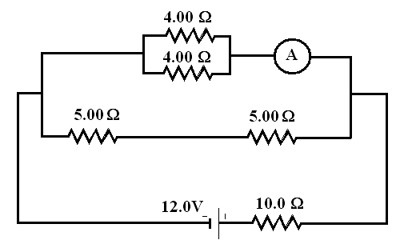
- Calculate the total circuit resistance.
(3 marks)

R1 = (4⁻¹ + 4⁻¹)
= 2 Ω

R2 = 5 + 5 = 10 Ω [1 mark]

R4 = (2⁻¹ + 10⁻¹)
= 1.6667 Ω [1 mark]

R(total) = 10 + 1.6667
R_{T} = 11.7 Ω [1 mark]

- Calculate the total current through the circuit. (2 marks)

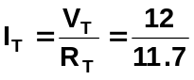 [1 mark]
I_{T} = 1.0286 A [1 mark]

- Calculate the potential difference across the 10.0 Ω resistor. (2 marks)

R₃ = 10 Ω V = IR
I_{T} = 1.0286 A = 1.0286 x 10 [1 mark]
V_{10Ω} = 10.286 V [1 mark]

- Calculate the potential difference across one of the 5.00 Ω resistors. (2 marks)

V across both 5Ω resistors = 12.0 – 10.286
= 1.714 V [1 mark]

As each resistor has half the potential difference,

V for one 5Ω resistor = 1.714 ÷ 2
= 0.857 V [1 mark]

- What is the reading on the ammeter? (3 marks)

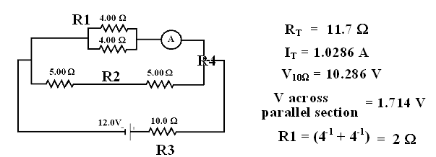

From the above data

R (4 Ω parallel section) = 2.0 Ω
V (4 Ω parallel section) = 1.714 V [1 mark]

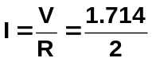 [1 mark]

I = 0.857 A

So ammeter = 0.857 A [1 mark]

- If the 4.00 Ω resistors were connected in series rather than in parallel, would the reading on the ammeter increase, decrease or stay the same? Without any calculations, explain your answer.
(3 marks)

DECREASE [1 mark]
Current is inversely proportional to resistance therefore increase resistance and current decreases. [1 mark]
When 4.0 Ω resistor put in series total resistance goes from 2.0 Ω to 8.0 Ω, as resistance has increased, current has decreased so metre reads less. [1 mark]

6. The resistance is the measure of how much ‘friction’ a conductor presents to an electric current. Consider the factors that affect resistance:
- Length (l). It is found that resistance increases proportionately with the length of a conductor
e.g. R ∝ l
- Cross-sectional area (A). The greater the cross-sectional area of a conductor, the smaller its resistance. e.g. R ∝ 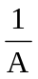
- Resistivity of the material (ρ - pronounced ‘rho’). An electrical property of materials is their resistivity. The resistance of a conductor is proportional to its resistivity; e.g. R ∝ ρ

These relationships can be combined as follows:
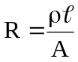
where R = resistance in ohms (Ω)
ρ = resistivity in ohm metres (Ωm)
l = length in metres (m)
A = cross-sectional area in square metres (m²)

A group of students were investigating the change in resistance of a metallic wire with a cross-sectional area of 1.257 x 10⁻⁷ m² against the length of wire used. They set up a circuit with a constant 12.0 V and measured the current in 0.25 m of the wire. They then increased the length of the wire from 25 cm to 100 cm in 25 cm increments and again measured the current each time.

- For this investigation name the:
  - independent variable. Length of wire (1 mark)
  - dependent variable. Current (1 mark)
  - two control variables. Same PD, same diameter of wire, same material, etc (2 marks)
- Write an appropriate hypothesis for this experiment. (2 marks)

As the length of the wire is increased then the current of the wire decreases.
[1 mark answer with no ratio]

As the length of the wire is increased doubled, then the current of the wire decreases by half.
[2 mark answer with ratio]

- The data they collected is shown below. Complete column three of the table to show the resistance of the wire at various lengths. (2 marks)

Length (m) | Current (A) | Calculated resistance (Ω)
0.25 | 0.060 | R = 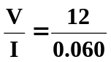 = 200
0.50 | 0.030 | 400
0.75 | 0.020 | 600
1.00 | 0.015 | 800

- Calculate the resistivity of the first line of data, show your working below. (3 marks)

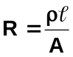
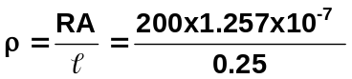 [1 mark]
= 1.0056 x 10⁻⁴ Ωm [1 mark]

- If the radius of the wire was doubled, the value of the resistance would
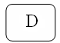
    - double
    - say the same
    - halve
    - quarter answer (1 marks)

- If the resistance of the wire was doubled, the value of the resistivity would

    - double
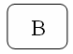
    - say the same
    - halve
    - quarter answer (1 marks)

g. if the length of the wire was halved, the value of the resistance would

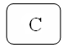
- double
- say the same
- halve
- quarter answer (1 marks)

7. An electrical circuit is set up by a teacher to test students understanding of current, resistance and potential difference. The meters used in the circuit do not have any influence on the circuit other than to register current and potential difference. The students could see the readings on five of the meters but the teacher had covered the dials of three of the meters so the students could not see what they registered. A diagram of the circuit is below.

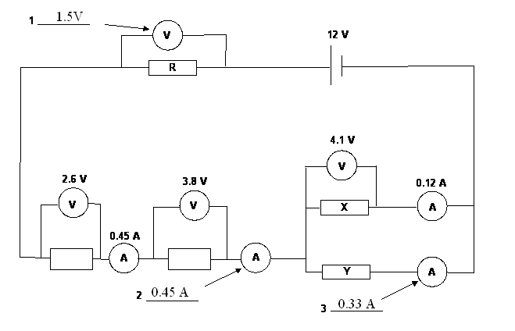

a. Calculate what the readings on the three meters would be, and write the values next to the meters
in the spaces provided. (3 marks)

V = 12 – (2.6 + 3.8 + 4.1) = 1.5 V [1 mark]

A = 0.45 A [1 mark]

A = 0.45 – 0.12 = 0.33 A [1 mark]

b. Calculate the resistance of X. (2 marks)

V = I.R
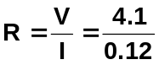 [1 mark]
R = 34.2 Ω [1 mark]

c. Calculate the quantity of charge which flows through resistance Y in 5.0 min. (2 marks)

q = I t
= 0.33 x 5 x 60 [1 mark]
= 99 C [1 mark]

d. Calculate the value of resistance R. (2 marks)

V = I R
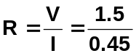 [1 mark]
R = 3.33 Ω [1 mark]

Section three: Comprehension 16 marks

This section has one (1) question. Answer in the spaces provided.
Suggested working time for this section is 20 minutes.
Solar Cells – converting sunlight into electricity

In the midst of the debate about global warming and obvious problems such as the disastrous BP oil spill in the Gulf of Mexico this year, alternatives to coal, oil and gas are urgently sought. Clean, renewable energy is a vision shared by many.

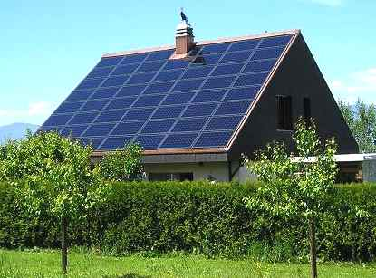
An energy source that is increasingly viable is from Solar Cells that convert sunlight into electricity. You may have seen arrays of solar panels on rooftops in Perth. So how do they work?

A basic explanation is as follows. The solar cell consists of 2 thin layers of a semiconducting material such as silicon which have different electrical properties. Many cells are spread over a large surface area in a panel. Sunlight shines onto the panel and light energy is transferred into electrons within the silicon. These electrons can be driven through an external load with the solar panel acting as a source of emf.

The electrical conduction properties of a semiconductor such as silicon are altered by adding impurities in a process known as ‘doping’. An n-type semiconductor is made by adding atoms such as arsenic which give the semiconductor an excess of free electrons. A p-type semiconductor is doped with materials such as aluminium or indium which give the semiconductor a deficiency of electrons known as ‘holes’.

Load resistor
A thin upper layer of n-type semiconductor is bonded to a layer of p-type semiconductor
n-type material
p-type material
electrical contacts
Electrons from the n-type material fill into holes of the p-type material near the junction
Atomic electrons energised by sunlight follow an external path from n to p

Consider a solar cell when no sunlight shines on it. At the junction between the n-type and p-type materials, electrons from the n-type migrate into the holes of the p-type, this leaves the n-type layer with a net positive charge and the p-type layer with a net negative charge. An electric field is established across the junction. The field strength increases until equilibrium is reached making it harder for electrons to cross from the n-side to the p-side. Now the electric field behaves like a ‘diode’ which only allows other electrons to cross in the direction p to n.

When sunlight shines onto the solar cell, a photon of light absorbed near the junction can free an electron in the atomic structure and leave a positive hole. This free electron is forced across the junction to the n-type layer and the hole effectively moves to the p-type layer by successive electrons filling the hole but forming another hole where they came from. If an external conducting path with a load resistance is connected between the n-type layer and the p-type layer then electrons will flow from the n-type layer through the external path and back to the p-type layer to fill into a hole.
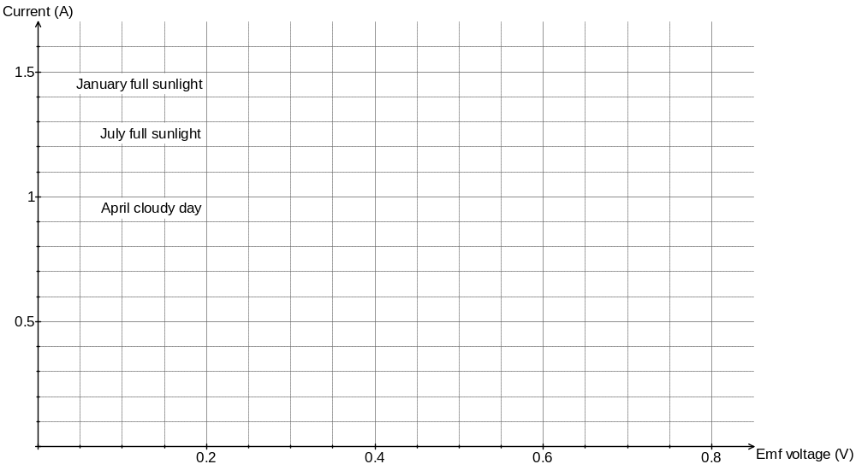
P_{max}

The graph shows the typical electrical output characteristics for a solar cell in Perth. The maximum power for ‘January full sunlight’ is indicated by P_{max}.

Maximum power from a solar cell is achieved by carefully setting the load resistance. When load resistance is too high a high voltage can be achieved but only with very low current. A low resistance can maximise current but the voltage will be much lower.

When purchasing solar panels there are important factors to consider. The high cost means that it can take many years to payback the financial outlay. Reliability is critical although many manufacturers now offer a 25 year warranty. The cells supply DC but household items run on AC so an ‘inverter’ is needed for the conversion. Western Power like many other utilities will now buy excess electricity produced by a solar powered household, so this, along with government subsidies, can make a purchase feasible.

Questions

- Explain how a semiconductor such as silicon can be made to have an excess of free electrons
(2)
To make an n-type semiconductor impurities ✓such as arsenic are added to the silicon ✓

- What is the net electrical charge of a ‘hole’? Circle the correct response. (1)

A. Neutral B. Positive C. Negative D. Positive or negative depending on location

- Explain how a ‘hole’ can effectively move through the atomic structure of silicon.
(2)
An electron fills into a hole but in doing so leaves a hole where it came from. This hole is filled by an electron leaving another hole. ✓ This process continues and can be viewed as a hole moving backwards. ✓ (or similar)

- What is the direction of conventional current through an external load resistor connected to the cell?
(2)
From the p-type layer at the bottom through the external path to the n-type layer on top. ✓ ✓

- Use the graph to estimate the maximum power output of a solar cell in January full sunlight. Clearly indicate how you obtained data from the graph.
(3)
obvious graph reference ✓
emf = 0.435 V (+/- 0.01) I = 1.24 A (+/- 0.01) ✓
P = V.I
P = 0.435 × 1.24 = 0.5394 P = 0.539 W ✓

- Refer to the 3 curves on the graph for this question and circle the best response.
For an output voltage of 0.1 V the load resistance is -
(1)
A. Too high in all cases B. Too low in all cases

C. Could be either depending on sunlight D. Impossible to determine

- Solar panels supply DC. What problem does this cause when feeding electricity back to the Western Power grid and how is this problem solved?
(2)
Western Power grid is AC. ✓This is solved by use of an inverter which converts the DC into an AC waveform. ✓

- A typical solar panel is 18% efficient in terms of converting the energy in sunlight to electrical energy. Calculate the amount of solar energy required per second for a solar panel with an electrical output of 432 W.
(3)
432 W = 18% of 100% of energy per second supplied by solar energy ✓

Efficiency (%) = (energy taken / energy offered) × 100
0.18 = 432 / Solar energy ✓

Solar energy = 432 / 0.18 = 2400 Joules per second ✓

End of questions

Additional working space

Additional working space

